ToF sensor dimensions (inch)
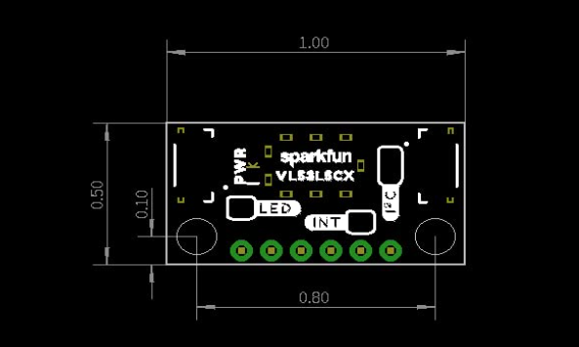
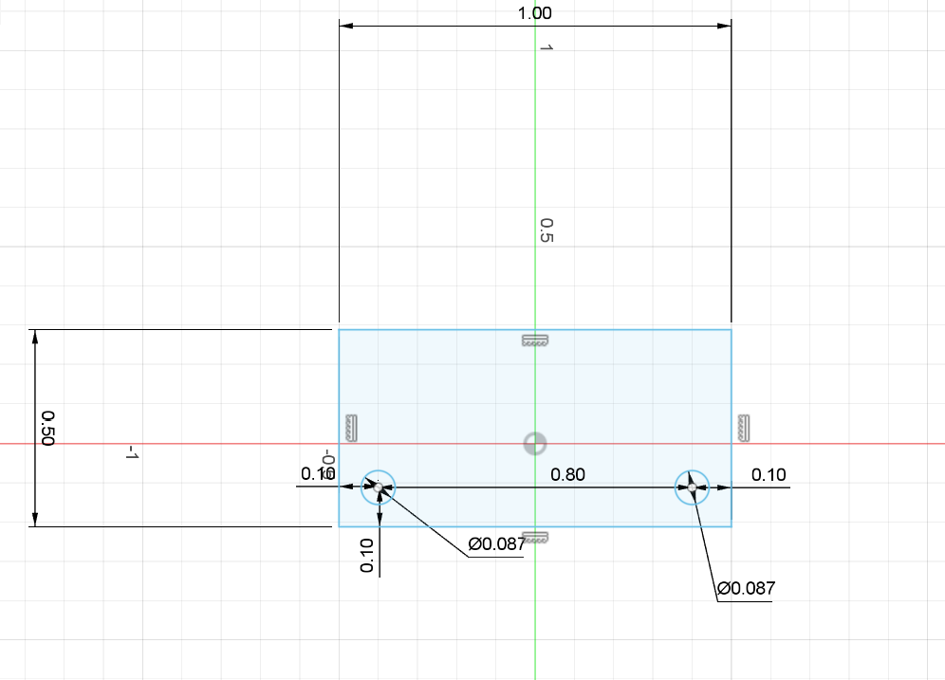
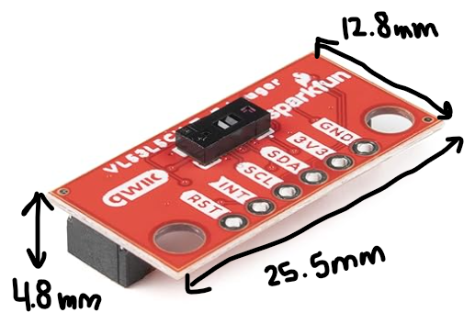

IR Sensor:
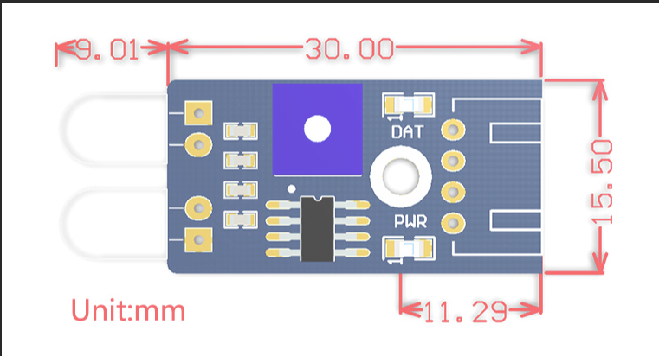

Arm Dimensions:
TOF:
- 34 mm wide/ 1.34 in

IR:
- 35.5 mm / 1.4 in

Screw Diameter:
13.5mm

